Roy and Profile Picture
#include<stdio.h>
int main(){
int L,N,W,H;
scanf("%d%d",&L,&N);
for (int i = 0;i<N;i++){
scanf("%d%d",&W,&H);
if(L > W || L > H){
printf("UPLOAD ANOTHER");
}else if(W == H){
printf("ACCEPTED");
}else {
printf("CROP IT");
}
printf("\n");
}
return 0;
}
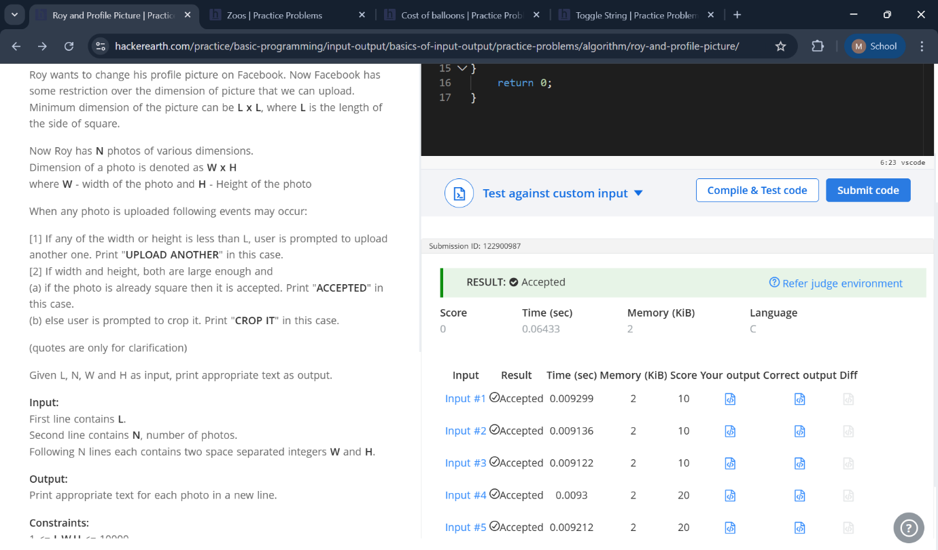

Zoos
#include<stdio.h>
#include<string.h>
int main(){
char arr[21];
scanf("%s",arr);
int length = strlen(arr);
int x=0,y=0;
for(int i = 0;i<length;i++){
if (arr[i] == 'z'){
x++;
}else{
y++;
}
}
if(2*x == y){
printf("Yes");
}else{
printf("No");
}
printf("\n");
return 0;
}


Cost of balloons
#include <stdio.h>

int main() {
int t;
scanf("%d", &t);

while (t--) {
int costG, costP;
scanf("%d %d", &costG, &costP);

int n;
scanf("%d", &n);

int a = 0, b = 0; // a = total who solved problem1, b = problem2

for (int i = 0; i < n; i++) {
int p1, p2;
scanf("%d %d", &p1, &p2);

a += p1; // if participant solved problem1
b += p2; // if participant solved problem2
}

long long cost1 = (long long)a * costG + (long long)b * costP;
long long cost2 = (long long)a * costP + (long long)b * costG;

printf("%lld\n", (cost1 < cost2 ? cost1 : cost2));
}

return 0;
}

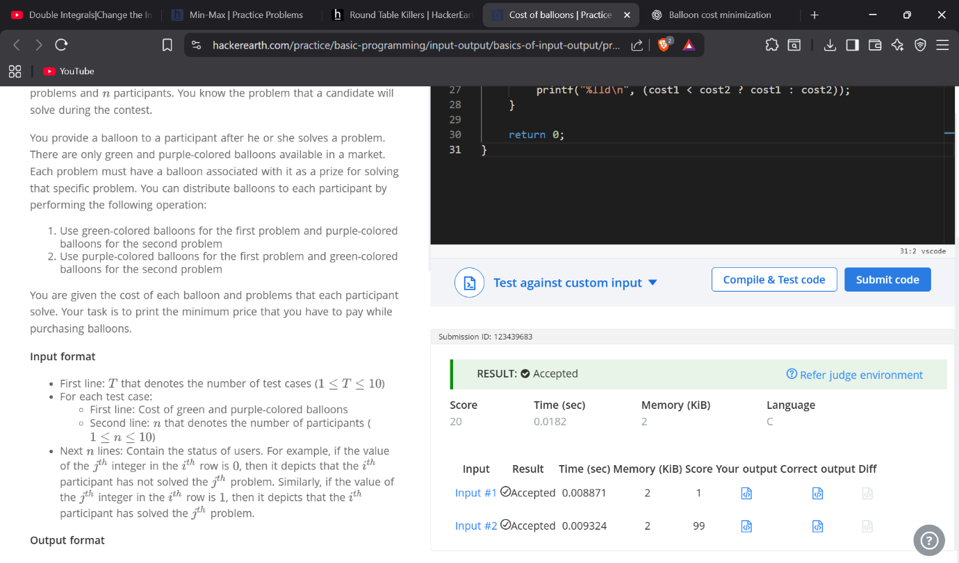

Toggle String

#include<stdio.h>
#include<string.h>
int main(){
char str[101];
scanf("%s",str);
int l = strlen(str);
for(int i = 0;i<l;i++){
//lowercase to uppercase
if(str[i] > 96 && str[i] < 123){
str[i] -= 32;
}
//uppercase to lowercase
else if(str[i] > 64 && str[i] < 91){
str[i] += 32;
}
}
//for(int i = 0;i<l;i++){
printf("%s",str);
//}
}

